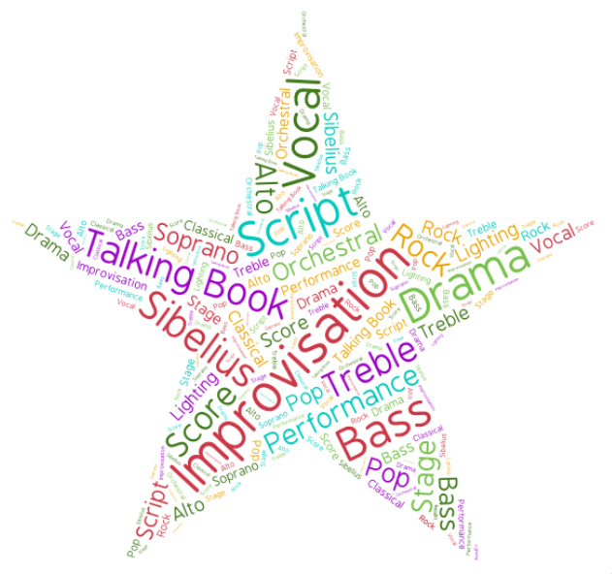

Friends of Yeovil Performing Arts Library (FYPAL) was formed by a group of local singers and musicians who are passionate about sharing their love of music, song and drama. We are very much community focused and we believe everyone should have the arts in their lives, especially as they can help with day-to-day health and wellbeing issues. Being part of a choir, orchestra or drama group enables people to make new friends and have a reason to go out.
We raise funds via donations, retail cashback, coffee mornings, the sale of greetings cards and the loan of music produced by the Wyvern Composers Group who meet weekly in PAL. Details below. All income aids the purchase of new vocal and orchestral scores and drama playsets, which can be loaned via PAL, by groups who wish to put on concerts and plays for the benefit of the community.
Please share information from our Newsletter with your groups and other people who you think may be interested. We cannot have too much support.
A programme of Events for 2017 will soon be available when details have been finalised. Please support us to keep performing arts alive in our community.

Forthcoming Events at PAL – All take place on 2nd Floor Yeovil Library
Friends of Yeovil Performing Arts Library
Newsletter - Autumn 2016

11.00 am - 18 November 2016 - Coffee Morning – Come in and pick up a piece of music and play our keyboard, if you don’t play come in anyway and join us for coffee/tea and of course homemade cake (reasonable prices). Our music themed greeting cards will be available to order. Poster following.
2.00 pm - 3 December 2016 – A History of Carols - An informal talk with musical accompaniment on the history of nine traditional carols. £1.50 per person. Book to avoid disappointment. Tel: 01935 472020. (This is a non Friends event.)
11.00 am - 16 December 2016 – Coffee Morning – Community Carol Singing – Open to all A nice change from the bustle of shopping. Everyone’s welcome to come and join us for coffee/tea, mince pie and a sing song. (Refreshments at reasonable prices.) So take some time out of your busy day and join us. Our music themed greeting cards will be available to order.
11.00 am - 17 December 2016 – Bronco Hutchings Ensemble – Come and listen to a variety of seasonal music played by talented local musicians. Free event, no need to book just come in and rest your feet for a while. Our music themed greeting cards will be available to order.
Other information:
Volunteering – A couple of us volunteer a few hours a week, mainly with shelf tidying, but we also cover new and old editions as required, in the hope that the covers will extend book life. Tel: 01935 472020 and speak to Mandy for further information if you have some free time.

How we raise funds:
Donations – We accept donations large or small as everything helps towards our goal. From personal donations to ‘small change’ collections in choir tea breaks, every penny counts.
Sale of Greeting Cards – We’ve included a poster showing blank greeting cards which is one of our new fund raisers. All cards have a music theme and are available to order - £1.75 ea. Cards are FSC Certified. Produced in the UK, cello wrapped with white envelope. Currently 10 cards to choose from. To place an order contact via our FB/Twitter/email feeds or ring Sue on 07905770757.
Coffee Mornings – Help raise funds by the purchases of coffee/tea and of course homemade cake.
Retail (cashback) Donations – How they work. (Statement from easyfundraising)
Whenever you buy anything online - from your weekly shop to your annual holiday - you could be collecting free donations for Friends of Yeovil Performing Arts Library.
When you shop the easyfundraising way, with one of our 3,141 shops and sites, they are ready to make a donation and give us a commission for your purchase we then turn that into a donation and give it to your good cause. Incs Ebay, Amazon, John Lewis, Aviva, thetrainline and Sainsbury's – it doesn't cost you a penny extra!
1. Go to https://www.easyfundraising.org.uk/causes/yeovilperformingarts/ and join for free.
2. Every time you shop online, go to easyfundraising first to find the site you want and start shopping.
3. After you’ve checked out, that retailer will make a donation to your good cause, in the form of commission for you using their site at no extra cost to you whatsoever!
There are no catches or hidden charges and Friends of Yeovil Performing Arts Library will be extremely grateful for all your donations.
Thank you in anticipation of your support
Wyvern Composers Group – Music composed by the group will be available for loan via PAL.

If you’d like to join us, have any questions, or you’re a musician / singer who would consider giving us some of your free time for fund raising events, and for all other enquiries please contact us via:
Friends of Yeovil Performing Arts Library @FriendsofYPAL FriendsofYeovilPAL@mail.com

Coffee Morning at Yeovil Library
organised by
Friends of Yeovil Performing Arts Library
We are holding our first Coffee Morning in PAL, 2nd floor Yeovil Library, at 11.00am on Friday 18 November 2016.
If you play piano come on in, take some music from a shelf and have a tinkle on the ivories.
If you don’t play please come in anyway and see our wonderful greeting cards which will be available to order at £1.75 ea. The cards are painted, printed and packed in the UK. FSC Certified card. All blank inside, cello wrapped with a white envelope.
All proceeds go towards the purchase of vocal/music scores and playsets which benefit singers, musicians and thespians alike.
We’ve currently 10 cards to choose from, illustrated below. To place an order make contact via our FB/Twitter/email feeds or ring Sue on 07905770757.
Coffee / tea and homemade cake will be available, at reasonable prices, so please come in and see us.
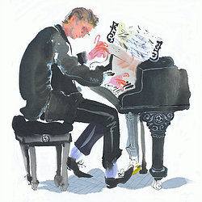
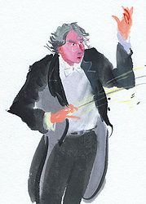
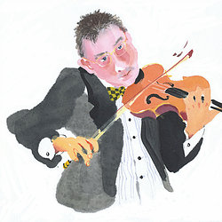
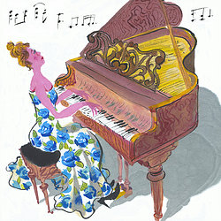
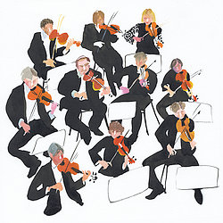
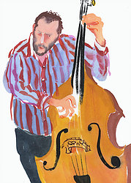
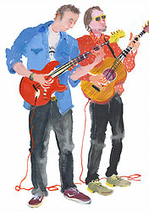
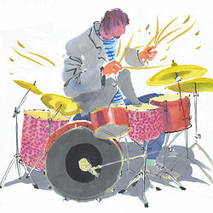
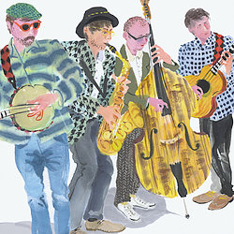
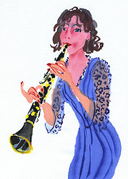

Friends of Yeovil Performing Arts Library @FriendsofYPAL FriendsofYeovilPAL@mail.com

Forthcoming Events at PAL
organised by
Friends of Yeovil Performing Arts Library
(unless otherwise stated)

All events take place 2nd Floor Yeovil Library

11.00 am – Fri 18 November 2016 - Coffee Morning – Come in and pick up a piece of music and play our keyboard, if you don’t play just come and listen to the music and join us for coffee/tea and of course homemade cake (reasonable prices). Our music themed greeting cards will be available to order.
2.00 pm - Sat 3 December 2016 – A History of Carols - An informal talk with musical accompaniment on the history of nine traditional carols. £1.50 per person. Book to avoid disappointment. Tel: 01935 472020. This is a non Friends event.
11.00 am – Fri 16 December 2016 – Coffee Morning – Community Carol Singing – Open to all - A nice change from the bustle of shopping. Everyone’s welcome to come and join us for coffee/tea, mince pie and a sing song. (Refreshments reasonably priced.) So take some time out of your busy day and join us. Our music themed greeting cards will be available to order.
2.00 pm – Sat 17 December 2016 – Bronco Hutchings Ensemble – Come and listen to seasonal music played by talented local musicians. Free event, no need to book just come in and rest your feet a while. Our music themed greeting cards will be available to order.

